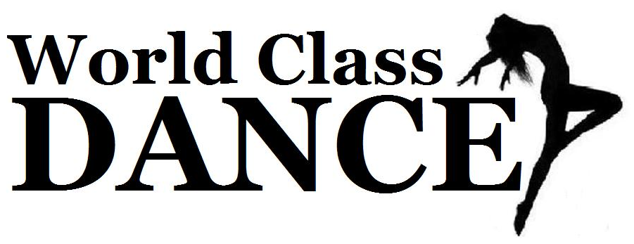OUR WORLD NEWS 
Dear World Class Dance families,
As mentioned in last month’s news letter, our instructors have been evaluating our dancers and have begun asking some to change their dance day/time that best fit their dance level. Now we are creating classes and combining students to make sure we have the appropriate number of students to be considered a “class”. (As stated in our policies: a “class” consists of 4 or more students). We appreciate your patience and understanding as we continue building our Dance School.
Your 1st of 3 tuition installments is now due. Tuition must be paid in full BEFORE a dancer is allowed to continue with lessons. Your next Tuition Payment is due on or before December 1st. Also, Recital Costume Payments will be due by Dec 15th. There is a $50 Costume fee per class, which does NOT include tights or recital/Finale’ performance shirt. (This does NOT apply to team dancers. Teams will have separate forms/fees) All Dancers must purchase the required tights and recital shirt through World Class Dance. We will provide you with a costume order form when you submit your next tuition payment.
All dancers must have the required uniform shirt & dance shoes purchased through World Class Dance. If you have not yet been sized, please do so as soon as possible. Dance shoes that were on back order should be here within the next 2 weeks. We apologize for any inconveniences, and appreciate your understanding. More shirts just arrived!
BRING A FRIEND WEEK October 14th-19th. During this week all of our current dancers may bring a friend(s) to dance class with them. Please make sure to WEAR YOUR WORLD CLASS DANCE UNIFORM SHIRT during this week. If your friend registers in one of our full season/recital classes by Oct 20th, you will receive a water bottle for FREE!!!! Share our fun dance world with all your friends!
On October 20th 12:30-4:00, we will hold OPEN AUDITIONS for our Dance Teams. We offer 4 levels of teams ages 4-18: Pixie (ages 4-6, NO exp required) Mini (ages 7-10) , Jr (ages 10-13), & Sr Team (ages 13-18) all 3 levels must have TAP experience. So if you or someone you know may be interested please let them know about our auditions. Again…If a referred friend joins team you will receive a water bottle for FREE!!!
Our Dance Team members will be participating and performing during Clifton Park Centers MALLOWEEN event. This will be held on Saturday October 26th 3:00-5:00. Come support our Dance Teams, enjoy the fun and WEAR YOUR WORLD CLASS DANCE UNIFORM SHIRT!
Our first OBSERVATION PERFROMANCE WEEK will be November 4th-9th. This week parents, friends and family may come in the last 10-15 minutes of class and watch your dancers “perform” for you. This is a great opportunity for your dancer to start having an audience and for you to view what they have been learning thus far. Please make sure all dancers WEAR YOUR WORLD CLASS DANCE UNIFORM SHIRT!
Thank You, Miss Erica


